**PROTOTYPING OF BUILDING AUTOMATION SYSTEMS**

Project Report

*Submitted by*

**T. V. VIGNESH GAURAV ANAND**

100906133 100906537

*Under the guidance of*

**Mr.Vedavyasa Kamath**

*In partial fulfilment of the requirements for the award of the degree of*

**BACHELOR OF TECHNOLOGY**

**IN**

**ELECTRICAL AND ELECTRONICS ENGINEERING**



**DEPARTMENT OF ELECTRICAL AND ELECTRONICS ENGINEERING**

**MANIPAL INSTITUTE OF TECHNOLOGY**

(A Constituent College of Manipal University)

MANIPAL – 576104, KARNATAKA, INDIA

**May 2015**

**DEPARTMENT OF ELECTRICAL AND ELECTRONICS ENGINEERING**

**MANIPAL INSTITUTE OF TECHNOLOGY**

(A Constituent College of Manipal University)

MANIPAL – 576 104 (KARNATAKA STATE), INDIA

Manipal

16 May, 2015

**CERTIFICATE**

This is to certify that the project titled “**PROTOTYPING OF BUILDING AUTOMATION SYSTEMS”** is a record of the bonafide work done by **T. V. VIGNESH** (Reg. No. 100906133) and **GAURAV ANAND** (Reg. No. 100906537) submitted in partial fulfilment of the requirements for the award of the Degree of Bachelor of Technology (B. Tech.) in Electrical and Electronics Engineering (E & E Engg.) by Manipal Institute of Technology Manipal, Karnataka (A Constituent College of Manipal University), during the academic year 2014-15).

|  |  |
| --- | --- |
| **Mr. Vedavyasa Kamath**  *Project Guide* | **Dr. Savitha G. Kini**  *HOD, Dept of E & E Engg.* |

**ACKNOWLEDGMENTS**

This project was possible with assistance of many faculty members from the electrical department and using resources available in the college.

First, we would like to thank our project guide **Mr. Vedavyasa Kamath**, Asst. Professor, Dept. of Electrical & Electronics Engg. for helping us set our goals and helping us in the advent of problems and also driving us to work more.

We wish to express our sincere gratitude to **Dr. Savitha G. Kini**, HOD, Dept. of Electrical & Electronics Engg., for providing us the space to work and use lab equipment when needed.

We are grateful to **Dr. Ciji Pearl Kurian** & **Mrs. Divya Shetty**, UG Project Coordinators, for providing us with valuable suggestions and advice throughout our project.

We are obliged to all our teachers and lab technicians, for the valuable information provided by them in their respective fields.

**ABSTRACT**

With the rise in growth of new inventions in the field of science and technology, building owners are beginning to look outside the four walls and consider the impact of their building on the electrical grid, the mission of their organization, and the global environment. To meet these objectives, it is not enough for a building to simply contain the systems that provide comfort, light and safety. Smart building of the future must connect the various pieces in an integrated, dynamic and functional way. Thus, it becomes necessary to make the controlling of these devices easy and efficient. This makes automation and control a very important necessity in the modern day scenario so that the user remains in sync with all the devices around him and monitor its activities remotely from anywhere and also make sure the operation is efficient.

In the project work, a prototype of a building automation system (BAS), with Raspberry Pi as the base station and Arduino as substations is used along with power electronic devices to monitor and control several subsystems of a building. Graphical user interface developed for user friendly interaction ensures control and monitoring of subsystems from anywhere in the world.

Primary objectives of a BAS such as sensing and control of lighting devices, security system control, monitoring temperature and humidity are achieved in the prototype.

An effort is made to demonstrate the concept of building automation system. The prototype acts as a model for budding engineers on how to implement a real world Building Automation System.

**LIST OF TABLES**

|  |  |  |
| --- | --- | --- |
| **Table No.** | **Table Title** | **Page No.** |
| 1.1 | Project Timeline | 2 |
| 2.8 | Comparison between Ballasts | 6 |
| 3.3.1 | Electronic Ballast Specifications | 28 |
| 3.3.2 | Fluorescent Lamp Specifications | 28 |
| 3.3.3 | DHT11 Temperature & Humidity Sensor Specifications | 28 |
| 3.3.4 | Raspberry PI 2 Model B Specifications | 28 |
| 3.3.5 | Arduino UNO Specifications | 29 |
| 3.3.6 | AC FAN Specifications | 29 |

**LIST OF FIGURES**

|  |  |  |
| --- | --- | --- |
| **Figure No.** | **Figure Title** | **Page No.** |
| 2.5 | A Conventional Building Automation System | 6 |
| 2.12.x | PWM Duty Cycle | 8 |
| 2.18.1 | Configuration of SSRs | 9 |
| 2.18.2 | Switching AC Loads using SSRs | 10 |
| 2.19.1 | Voltage Amplification | 10 |
| 2.19.2 | OPAMP uA741 Pin Diagram | 11 |
| 3.1 | The System | 12 |
| 3.2.1 | Modular Representation | 12 |
| 3.2.2 | Detailed Representation of the system | 13 |
| 3.2.3 | Light Control and Sensing | 14 |
| 3.2.4 | Switching Devices using SSRs | 15 |
| 3.2.5 | Power Supply Conversion | 15 |
| 3.2.6 | RF Communication | 16 |
| 3.2.7 | Light Sensing | 17 |
| 2.15.1 | Typical LDR Light intensity vs Resistance Graph | 18 |
| 3.2.8 | Motion Sensing | 18 |
| 3.2.9 | Door Sensing | 19 |
| 2.17.1 | Reed Contacts | 20 |
| 3.2.10 | Temperature & Humidity Sensing | 20 |
| 3.2.11 | Switching Devices | 21 |
| 2.13.1 | NRF24L01+ Pin Diagram | 23 |
| 3.3 | Tools Used | 24 |
| 3.4 | Software & Languages Used | 24 |

|  |  |  |  |  |  |
| --- | --- | --- | --- | --- | --- |
| **Contents** | | | | | |
|  | | | | | Page No |
| Acknowledgement | | | |  | I |
| Abstract | | | |  | Ii |
| List Of Figures | | | |  | iv |
| List Of Tables | | | |  | Iii |
|  | | | | | |
| **Chapter 1** | | | **INTRODUCTION** | |  |
|  | **1.1** | Motivation | | | 1 |
|  | **1.2** | Literature Review | | | 1 |
|  | **1.3** | Objectives | | | 2 |
|  | **1.4** | Importance of end result | | | 2 |
|  | **1.5** | Project Timeline | | | 2 |
|  | | | | | |
| **Chapter 2** | | | BACKGROUND THEORY | |  |
|  | **2.1** | Importance of Building Automation Systems | | | 3 |
|  | **2.2** | Controllers & Actuators | | | 3 |
|  | **2.3** | A Conventional Building Automation System | | | 6 |
|  | **2.4** | Pulse Width Modulation | | | 8 |
|  | **2.5** | Solid State Relays | | | 9 |
|  | **2.6** | Voltage Amplification | | | 11 |
|  | | | | | |
| **Chapter 3** | | | **METHODOLOGY** | |  |
|  | **3.1** | The System | | | 12 |
|  | **3.2** | Block Diagrams | | | 12 |
|  | **3.3** | Tools Used | | | 24 |
|  | **3.4** | Software and Languages Used | | | 24 |
|  | | | | | |
| **Chapter 4** | | | **RESULT ANALYSIS** | |  |
|  | **4.1** | Analysis & Inference | | | 26 |
|  | | | | | |
| **Chapter 5** | | | **CONCLUSIONS & FUTURE SCOPE** | |  |
|  | **5.1** | Problem Statement | | | 31 |
|  | **5.2** | Summary of Methodology | | | 31 |
|  | **5.3** | Conclusion & Future Scope | | | 31 |
| **ANNEXURE** | | | | | 32 |
| **REFERENCES** | | | | | 34 |
| **PROJECT DETAIL** | | | | | 35 |

**CHAPTER 1**

**INTRODUCTION**

Building Automation Systems are the rising need in the modern day scenario due to the difficulty in monitoring and controlling the numerous number of devices leading to lot of loss in efficiency. Automating and controlling devices makes things easier for the user and allows to improve the efficiency of work.

Automating devices require the use of various technologies related to electrical, electronics, communication, computer science & engineering. All these are integrated together using proper protocols and gateways thereby making it easier for every device to understand each other. Considering all these in mind, the prototype has been made in such a way that communication between devices is made possible at ease using 433 MHz radio frequency transmission by appropriate transceivers.

1. **Motivation**

Building & Industrial Automation has been vastly implemented in places like automobile industries, big corporates, power stations etc. due to the large scale implementation of various technologies.

This prototype was made keeping in mind that the apparatus used is efficient as well as cost effective so as to make sure it is affordable for every person as opposed to the current automation systems which are very costly.

This prototype will be a base for designing a real world automation & control system since the model is made keeping in mind the real world scenario.

The methodology adopted is unique in a way considering the fact that a combination of microprocessors and microcontrollers are used in combination to control all the electronic and electrical devices. These devices communicate with each other in RF frequency through NRF24L01+ transceivers.

The end result will lead way to a new era of cost effective automation system which can easily be remotely controlled via any internet enabled handheld device.

1. **Literature Review**

Currently, companies like Siemens and Honeywell has been actively involved in development of a user friendly automation system using their own technologies from scratch. Some APIs have also been provided by them so that software developers could base their software on the automation systems. Many other individuals and private organizations have also been researching about the scope of Building Automation Systems in the future. We referred to some of the important works in the process of making the prototype. Mrs. Lady Ada is a professional Raspberry PI developer and CEO of Adafruit Industries working on Building Automation Systems and many of its related projects. Her papers on Accurate Temperature & Humidity sensing, Motion sensing were referred [1]. Mr. Lenotta is an Arduino developer working on communication systems. His papers on Secure RF transmission and reception using NRF24L01+ were referred [2]. We also referred to some papers which might help the future development of the project like Steven Hickson’s paper on Efficient Voice Recognition [3]. The remaining papers and other literature referred is listed in references section of the report.

From all their works, it was evident that efficient automation is possible by careful selection and usage of devices which are properly fabricated according to the requirements.

1. **Objectives**

The primary objectives of the work are:

* Control lighting system
* Sense lighting level
* Implementation of security systems like motion sensing and video capturing
* Monitor temperature and humidity
* Control switching of subsystems

Secondary objective is:

* Development of a user friendly GUI with the help of which the user can remotely monitor the system via hand held devices

1. **Importance of the end result**

This prototype will help hold itself as a model for budding engineers to get an overview of building automation systems thereby leading them in a cost effective development.

1. **Project Timeline**

Table 1.1: Project timeline

|  |  |
| --- | --- |
| **January 12-30** | Project Idea formulation, Block diagrams, Algorithms, Research |
| **Synopsis Presentation : Jan 27 - 31** | |
| **February 1-28** | Mobile Application Development, Server side development, Control of elementary devices |
| **March 1-30** | Enhancing the use of devices in the project, implementing automation, debugging |
| **Midterm Presentation : March 16-21** | |
| **April 1-30** | Circuit fabrication, testing, UI improvement |
| **May 1-10** | Soldering circuits, testing, RF Transmission |

**CHAPTER 2**

**BACKGROUND THEORY**

This chapter attempts to give a brief idea about the motivation for the project and similar work done in the past and the industrial applications relevant today.

1. **Importance of Building Automation Systems**

Building system data is an asset for any company. Every building is unique and energy consumption within all buildings varies and fluctuates, which should be managed in a unique manner. To be as lean as possible and maximize efficiency, this requires an intelligent Building Automation System (BAS) and a customizable graphic user interface (GUI) for unique dashboard creation to accurately visualize this information. Effective BAS visualization enables faster energy analysis, monitoring, and the ability to “tell the story” of the building performance to management, engineering, building operators and executives alike to make better decisions on ways to troubleshoot potential problems and cut costs.

1. **Controllers & Actuators**

Controllers are essentially small, purpose-built computers with input and output capabilities. These controllers come in a range of sizes and capabilities to control devices commonly found in buildings, and to control sub-networks of controllers.

Inputs allow a controller to read temperatures, humidity, pressure, current flow, air flow, and other essential factors. The outputs allow the controller to send command and control signals to slave devices, and to other parts of the system. Inputs and outputs can be either digital or analog. Digital outputs are also sometimes called discrete depending on manufacturer.

Controllers used for building automation can be grouped in 3 categories. Programmable Logic Controllers (PLCs), System/Network controllers, and Terminal Unit controllers. However an additional device can also exist in order to integrate 3rd party systems (i.e. a stand-alone AC system) into a central Building automation system).

PLC's provide the most responsiveness and processing power, but at a unit cost typically 2 to 3 times that of a System/Network controller intended for BAS applications. Terminal Unit controllers are usually the least expensive and least powerful.

PLC's may be used to automate high-end applications such as clean rooms or hospitals where the cost of the controllers is less of a concern.

In office buildings, supermarkets, malls, and other common automated buildings the systems will use System/Network controllers rather than PLC's. Most System controllers provide general purpose feedback loops, as well as digital circuits, but lack the millisecond response time that PLC's provide.

System/Network controllers may be applied to control one or more mechanical systems such as an Air Handler Unit (AHU), boiler, chiller, etc., or they may supervise a sub-network of controllers. In the diagram above, System/Network controllers are often used in place of PLCs.

Terminal Unit controllers usually are suited for control of lighting and/or simpler devices such as a package rooftop unit, heat pump, VAV box, or fan coil, etc. The installer typically selects 1 of the available pre-programmed personalities best suited to the device to be controlled, and does not have to create new control logic.

**Raspberry PI**

The Raspberry Pi is a low cost, credit-card sized computer that plugs into a computer monitor or TV, and uses a standard keyboard and mouse. It is a capable little device that enables people of all ages to explore computing, and to learn how to program in languages like Scratch and Python. It’s capable of doing everything you’d expect a desktop computer to do, from browsing the internet and playing high-definition video, to making spreadsheets, word-processing, and playing games.

What’s more, the Raspberry Pi has the ability to interact with the outside world, and has been used in a wide array of digital maker projects, from music machines and parent detectors to weather stations and tweeting birdhouses with infra-red cameras. We want to see the Raspberry Pi being used by kids all over the world to learn to program and understand how computers work.

**Arduino UNO**

The Arduino Uno is a microcontroller board based on the ATmega328. It has 14 digital input/output pins (of which 6 can be used as PWM outputs), 6 analog inputs, a 16 MHz ceramic resonator, a USB connection, a power jack, an ICSP header, and a reset button. It contains everything needed to support the microcontroller; simply connect it to a computer with a USB cable or power it with a AC-to-DC adapter or battery to get started.

The Uno differs from all preceding boards in that it does not use the FTDI USB-to-serial driver chip. Instead, it features the Atmega16U2 (Atmega8U2 up to version R2) programmed as a USB-to-serial converter. Revision 2 of the Uno board has a resistor pulling the 8U2 HWB line to ground, making it easier to put into DFU mode.

Revision 3 of the board has the following new features:

* 1.0 pinout: added SDA and SCL pins that are near to the AREF pin and two other new pins placed near to the RESET pin, the IOREF that allow the shields to adapt to the voltage provided from the board. In future, shields will be compatible with both the board that uses the AVR, which operates with 5V and with the Arduino Due that operates with 3.3V. The second one is a not connected pin that is reserved for future purposes.
* Stronger RESET circuit.
* Atmega 16U2 replace the 8U2.

**Electronic Ballasts**

Electronic Ballast is a device which controls the starting voltage and the operating currents of lighting devices built on the principle of electrical gas discharge. It refers to that part of the circuit which limits the flow of current through the lighting device and may vary from being a single resistor to a bigger, complex device. In some fluorescent lighting systems like dimmers, it is also responsible for the controlled flow of electrical energy to heat the lamp electrodes.

**Ballast Basics:**

For a lighting device based on electric gas discharge to work, the ionization of gas in the tube is necessary. This phenomenon takes place at a relatively high potential difference and/or temperature than the normal operating conditions of the lamp. After the arc is set up, the conditions can be brought down to normal. To achieve this, three types of methods are generally employed: *pre-heat, instant start and rapid start*.

In pre-heat, the electrodes of the lamp are heated to a high temperature before the voltage is impressed upon them through a starter. Instant start ballasts were developed to start lamps without delay or flashing and use an initial high voltage in place of raised temperatures. Rapid start ballasts make a tradeoff between pre-heat and instant start and use a separate set of windings to initially heat the electrodes for a lesser duration and then, using a relatively lower voltage to start the lamp.

Another type, programmed start ballasts is a variant of rapid-start. Any of these starting principles may be used in the ballasts. Initially, when the gas is unionized, it offers a high resistance path to current. But after the ionization takes place and the arc is set up, the resistance drops to a very low value, almost acting like a short circuit. If all this current is allowed to pass through the lamp, the lamp would either burn out or cause the power supply to fail. Thus the ballast needs to perform the current limiting.

**Types of Ballast:**

There are mainly three types of ballasts: magnetic, electronic and hybrid. Magnetic and hybrid ballasts employ a copper coil wound on a magnetic core as their essential components, while electronic ballasts use solid state electronic circuitry to provide the proper operating electrical conditions to the connected lamps. A brief comparison is tabulated below:

Table 2.8 Comparison between Ballasts

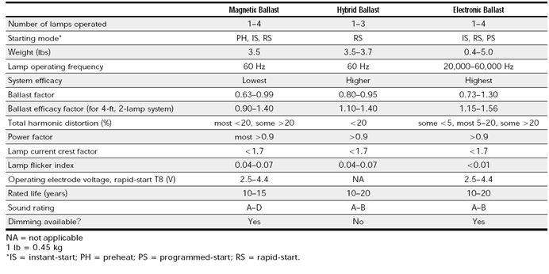

**Actuators**

An actuator is a type of motor that is responsible for moving or controlling a mechanism or system.It is operated by a source of energy, typically electric current, hydraulic fluid pressure, or pneumatic pressure, and converts that energy into motion. An actuator is the mechanism by which a control system acts upon an environment. The control system can be simple (a fixed mechanical or electronic system), software-based (e.g. a printer driver, robot control system), a human, or any other input.

1. **A Conventional Building Automation System**

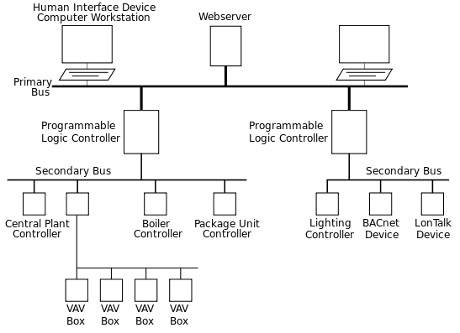

Fig 2.5 A Conventional Building Automation System

A conventionally designed Building Automation System has a webserver, which is the place where all the data is recorded and stored. It has a Workstation which acts as an interface for users to work on. It has a Programmable Logic Controller which controls all the secondary modules depending on the commands received from the webserver. It has protocols like BACnet, Lon works, etc. to communicate between devices. All these set of devices constitute a Conventional Building Automation System

Building automation systems (BASs) can be a powerful tool for commercial-building energy managers, but some managers are unsure about the prospective energy-savings benefits and first costs. A BAS might go into a building that has no existing system, replace outdated pneumatic controls, or replace an existing direct digital control system, but ultimately the energy savings will depend on how inefficiently the building was operating before installation. It’s possible, however, to make some generalizations about savings potential and costs. This can give energy managers who are considering BAS implementation a place to start—and help them work with energy providers to attain financial support.

Some of the most common strategies that BASs employ to cut energy use include:

* **Scheduling**—Scheduling turns equipment on or off depending on time of day, day of the week, day type, or other variables such as outdoor air conditions.
* **Lockouts**—Lockouts ensure that equipment doesn’t turn on unless it's necessary. For example, a chiller and its associated pumps can be locked out according to calendar date, when the outdoor air falls below a certain temperature, or when building cooling requirements are below a minimum.
* **Resets**—When equipment operates at greater capacity than necessary to meet building loads, it wastes energy. A BAS can ensure equipment operates at the minimum needed capacity by automatically resetting operating parameters to match current weather conditions. For example, as the outdoor air temperature decreases, the chilled water temperature can be reset to a higher value.
* **Diagnostics**—Building operators who use a BAS to monitor information such as temperatures, flows, pressures, and actuator positions may use that data to determine whether equipment is operating incorrectly or inefficiently, and to troubleshoot problems. Some systems also the use the data to automatically provide maintenance bulletins.

**Safety & Security**

Fire and Life Safety Automationintegration with the Automated Buildings is becoming critical.  The high level of interaction required between the active fire system, building wide communications, HVAC, and interactive smoke control systems that are normally part of the environmental control system has greatly increased the complexity of these systems.  Network standards can greatly simplify the sharing of information from the vital fire and life safety system**.**  Depending on the amount of shared data, the traditional method of providing an output from the fire and life safety system as an input to other automation systems may still be the best method.

1. **Pulse Width Modulation**

A Pulse Width Modulation (PWM) Signal is a method for generating an analog signal using a digital source. A PWM signal consists of two main components that define its behavior: a duty cycle and a frequency. The duty cycle describes the amount of time the signal is in a high (on) state as a percentage of the total time of it takes to complete one cycle. The frequency determines how fast the PWM completes a cycle (i.e. 1000 Hz would be 1000 cycles per second), and therefore how fast it switches between high and low states. By cycling a digital signal off and on at a fast enough rate, and with a certain duty cycle, the output will appear to behave like a constant voltage analog signal when providing power to devices.

Example: To create a 3V signal given a digital source that can be either high (on) at 5V or low (off) at 0V, you can use PWM with a duty cycle of 60% which outputs 5V 60% of the time. If the digital signal is cycled fast enough, then the voltage seen at the output appears to be the average voltage. If the digital low is 0V (which is usually the case) then the average voltage can be calculated by taking the digital high voltage multiplied by the duty cycle, or 5V x 0.6 = 3V. Selecting a duty cycle of 80% would yield 4V, 20% would yield 1V, and so on.

PWM signals are used for a wide variety of control applications. Their main use is for controlling DC motors but it can also be used to control valves, pumps, hydraulics, and other mechanical parts. The frequency that the PWM signal needs to be set at will be dependent on the application and the response time of the system that is being powered. Below are a few applications and some typical minimum PWM frequencies required:

* Heating elements or systems with slow response times: 10-100 Hz or higher
* DC electric motors: 5-10 kHz or higher
* Power supplies or audio amplifiers: 20-200 kHz or higher

Below are some graphs demonstrating PWM signals with different duty cycles.

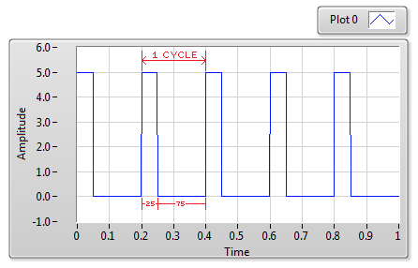 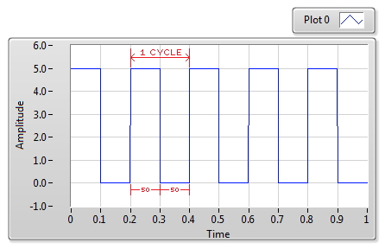

Fig 2.12.1 PWM with 25% Duty Cycle Fig 2.12.2 PWM with 50% Duty Cycle

1. **Solid State Relays**

SSRs (Solid State Relays) have no movable contacts. SSRs are not very different in operation from mechanical relays that have movable contacts. SSRs,however, employ semiconductor switching elements, such as thyristors, triacs, diodes, and transistors. Furthermore, SSRs employ optical semiconductors called photocouplers to isolate input and output signals. Photo couplers change electric signals into optical signals and relay the signals through space, thus fully isolating the input and output sections while relaying the signals at high speed.

SSRs consist of electronic parts with no mechanical contacts. Therefore, SSRs have a variety of features that mechanical relays do not incorporate. The greatest feature of SSRs is that SSRs do not use switching contacts that will physically wear out.

SSRs are ideal for a wide range of applications due to the following performance characteristics.

・ They provide high-speed, high-frequency switching operations.

・ They have no contact failures.

・ They generate little noise.

・ They have no operation noise.

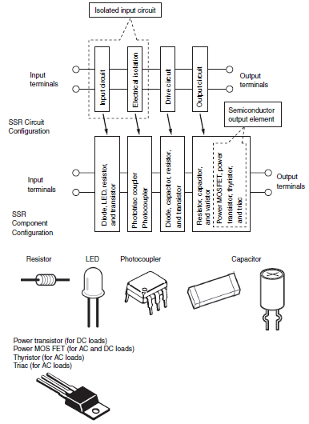

Fig 2.18.1 Configuration of SSRs

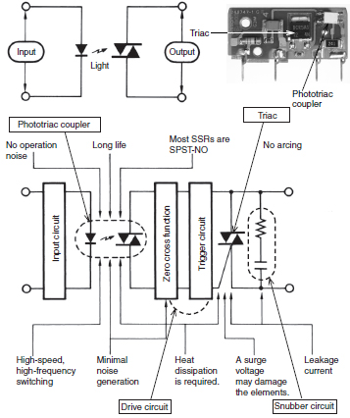

Fig 2.18.2 SSRs (Representative Example of Switching for AC Loads)

1. **Voltage Amplification**

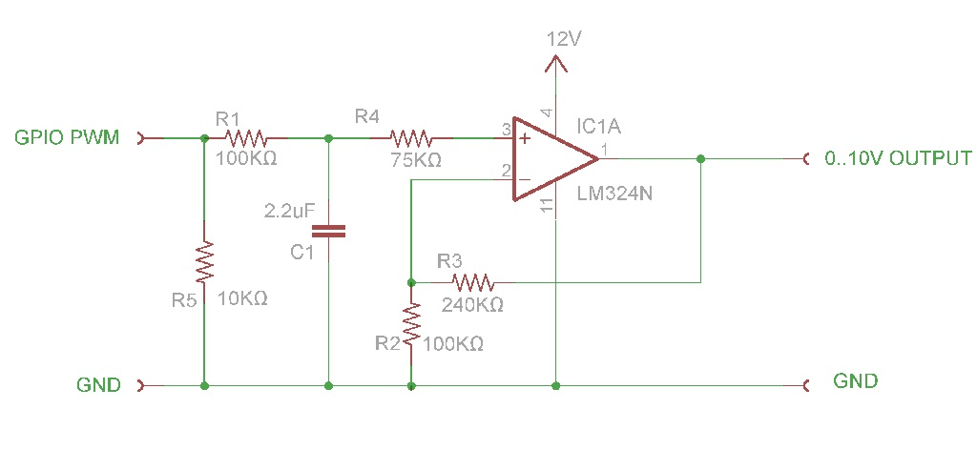

Fig 2.19.1 Voltage Amplification

The Figure 2.19 shows the Voltage Amplification circuit used as a sample for the prototype in the lighting module where a 0-3.3V PWM wave is amplified to 0-11V signal which is to be supplied to the electronic ballast.

The circuit shows a non-inverting Operational Amplifier circuit with +12V and -12 V supplies having a gain of approximately 3. The PWM signal is supplied to the non-inverting terminal of the amplifier while the amplified output is obtained in the output terminal of the OPAMP. The OPAMP used is uA741 which has the pin diagram as shown below.

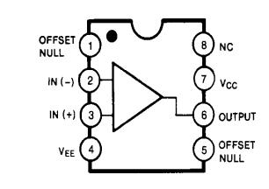

Fig 2.19.2 OPAMP uA741 PIN Diagram

**CHAPTER 3**

**METHODOLOGY**

1. **The System**

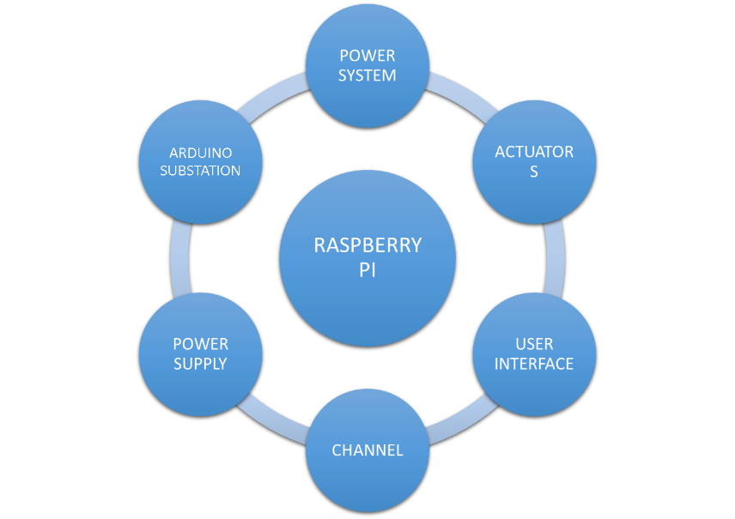

Fig 3.1 The System

Here, the Raspberry PI is a microprocessor which acts as a main station controlling the entire system via WiFi-RF communication protocols (Channel) using Arduino microcontrollers (Substation) which in turn control the power electronic devices (Actuators) which in turn control the power system devices. All these happens in sync with each other when the user interface sends a command to the microprocessor.

1. **Block Diagrams**
   1. **Modular Representation**

Fig 3.2.1 Modular Representation

This diagram shows the overall working of the system in simplest form. The Central Control Panel controls all the modules via the internet and radio frequency transmission.

* 1. **Detailed Representation of the System**

CENTRALIZED

MICROPROCESSOR

(RASPBERRY PI)

RF CHANNEL

INDIRECT I/O

INTERNET CHANNEL

Supporting Supply

I/O INTERFACE

(DIRECT ACCESS)

Actuators

Arduino Substation

Sensors

Plant

Fig 3.2.2 Detailed Representation of the system

This block diagram shows the overall outline of the prototype consisting of different modules. Raspberry PI microprocessor acts as a centralized system which is always connected to the server via internet thus keeping in touch with the data recorded in automation and also controlling all the Arduino Substations via RF communication. The user gives command via user interface which is sent to the Raspberry PI which in turn communicates the commands sent to the Arduino substations.

The Arduino substations work on controlling the Plant using Actuators (Power electronic Controllers) and the output from the Plant is sensed and again sent back to Arduino Substation which is sent back to Raspberry PI.

* 1. **Lighting Control and Sensing**

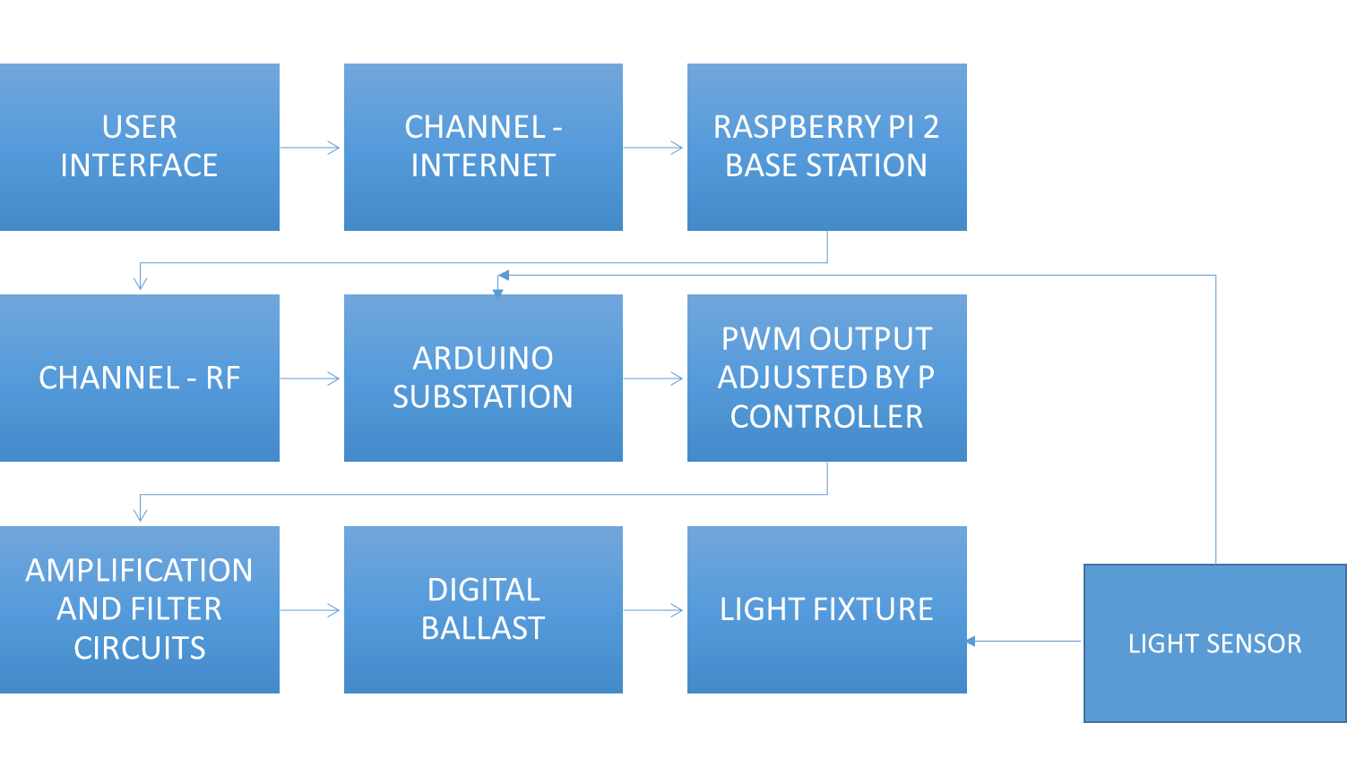

Fig 3.2.3 Light Control and Sensing

This block diagram demonstrates how the Lighting Control, Sensing and Automation works. The user sends the input from an interface which is received by the Raspberry PI microprocessor via internet which in turn processes the command and sends it to Arduino microcontroller substations via RF frequency transmission.

The Arduino receives the input from the user and accordingly generates a PWM signal with a specific duty cycle resulting in an output voltage of 0 to 3.3V. This voltage is in turn sent to an amplification circuit with a gain of approximately 2 and this becomes a voltage of range 0 to 10V. This voltage is supplied to an electronic ballast which controls the light fixture thus varying the intensity.

The intensity can then be sensed by a light sensing module having an LDR which sends the sensed light value to the microcontroller. This can later be used to automate the light and set it at a particular value.

* 1. **Switching Devices**

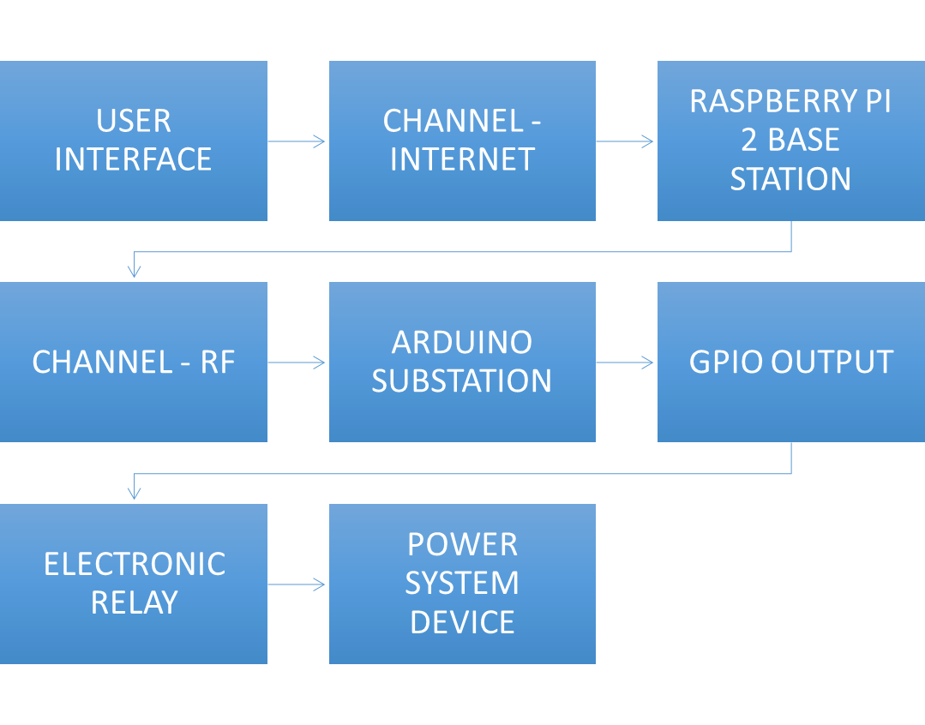

Fig 3.2.4 Switching Devices

This block diagram shows how any power system device is switched on/off. The command from user interface is sent via internet to Raspberry PI microprocessor which in turn processes the command and sends it via Radio Frequency channel to Arduino microcontroller which is nothing but the substation.

The Arduino then processes this input and accordingly sends a high or low voltage to the relay (0V or 3.3V) depending on whether the device should be on or off. The relay now does the job of switching on or off the power system device depending on the GPIO input received.

* 1. **Power Supply Conversion**

Fig 3.2.5 Power Supply Conversion

The block diagram shows how a 220V AC supply is stepped down using a step down AC transformer and then the obtained AC voltage is later rectified using diode bridge rectifier circuit to get a DC voltage with noise.

The obtained DC voltage is then regulated to get 12V using LM7812 regulators which is later given to the amplifier circuit as supply.

The LM78XX series of three terminal positive regulators are available in the TO-220 package and with several fixed output voltages, making them useful in a wide range of applications. Each type employs internal current limiting, thermal shut down and safe operating area protection, making it essentially indestructible. If adequate heat sinking is provided, they can deliver over 1A output current. Although designed primarily as fixed voltage regulators, these devices can be used with external components to obtain adjustable voltages and currents.

* 1. **RF Communication**

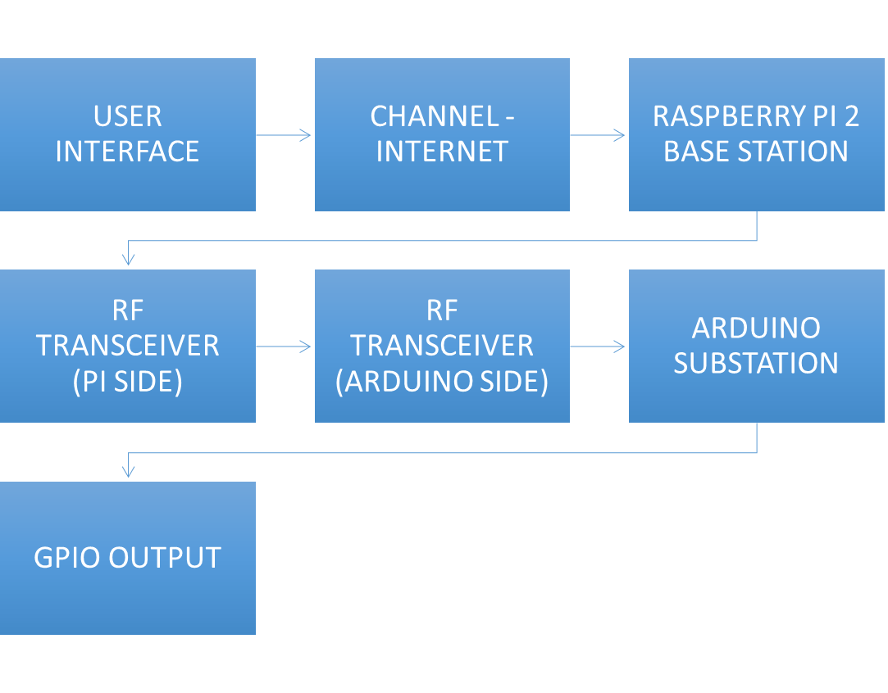

Fig. 3.2.6 RF Communication

The above diagram shows how the transmission and reception of RF signals happen in between Raspberry PI microprocessor and Arduino microcontroller.

First, the user gives a command via the user interface which is then sent via the internet to the Raspberry PI microprocessor (Base station). Now the received signal is processed and later sent to all the Arduino substations via the RF Transceiver chip (NRF24L01+) which is stationed both at the PI side as well as the Arduino side to communicate. Now, the received information is later used by the Arduino to perform appropriate actions like controlling the GPIO output.

* 1. **Light Sensing**

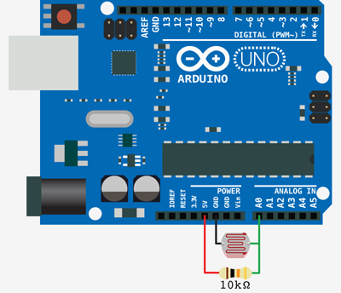

**ATMEGA 328**

Fig 3.2.7 Light Sensing

The above schematic shows how a LDR (Photo resistor) is connected to an Arduino microcontroller along with a resistor to protect the controller from overcurrent. LDR gives an analog output which is read by the Analog pins of the Arduino.

LDRs or Light Dependent Resistors are very useful especially in light/dark sensor circuits. Normally the resistance of an LDR is very high, sometimes as high as 1000 000 ohms, but when they are illuminated with light resistance drops dramatically.

An LDR is a component that has a (variable) resistance that changes with the light intensity that falls upon it. This allows them to be used in light sensing circuits.

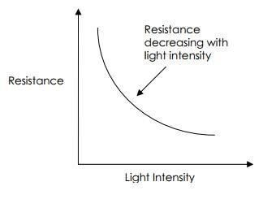

Fig 2.15.1 Typical LDR Light intensity vs Resistance Graph

* 1. **Motion Sensing**

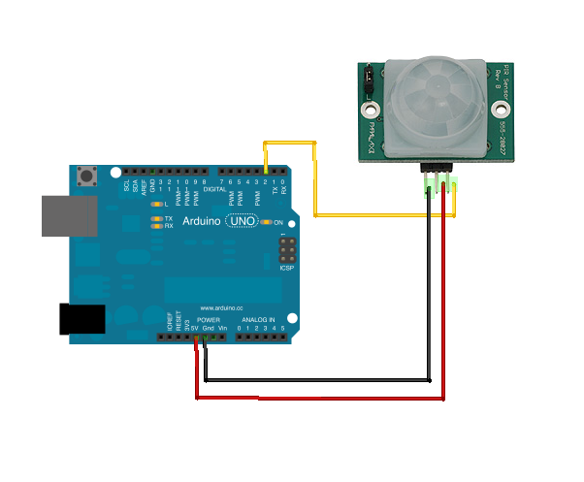

Fig 3.2.8 Motion Sensing

The schematic shows how a PIR motion sensor is connected to an Arduino microcontroller. There are 3 pins VCC, Ground and Output which are appropriately connected with VCC being 5V. The sensor sends a signal to the GPIO pin of Arduino once any motion is detected.

The sensor needs to be given a specific amount of time (10 seconds) to auto calibrate itself before use.

The sensors send out some IR signals to the area at a 280 degree angle of resolution and these signals are reflected back whenever a human body comes in contact with them. So, this allows the PIR sensors to detect motion at very fast intervals thus allowing a reliable operation.

* 1. **Doors Sensing**

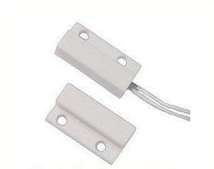

Fig 3.2.9 Door Sensing

The above picture shows a door sensor which is nothing but a reed relay with two magnetic contacts which acts like a switch allowing or blocking voltage flow depending on whether the two contacts are in range or not. A magnetic field is setup and when supply is given, the field activates. This is attached to two sides of door thus helping to decide whether the door is open or not.

Reed relay is a type of relay that uses an electromagnet to control one or more reed switches. The contacts are of magnetic material and the electromagnet acts directly on them without requiring an armature to move them. Sealed in a long, narrow glass tube, the contacts are protected from corrosion, and are usually plated with silver, which has very low resistivity but is prone to corrosion when exposed, rather than corrosion-resistant but more resistive gold as used in the exposed contacts of high quality relays. The glass envelope may contain multiple reed switches or multiple reed switches can be inserted into a single bobbin and actuate simultaneously. Reed switches have been manufactured since the 1930s.

As the moving parts are small and lightweight, reed relays can switch much faster than relays with armatures. They are mechanically simple, making for reliability and long life.

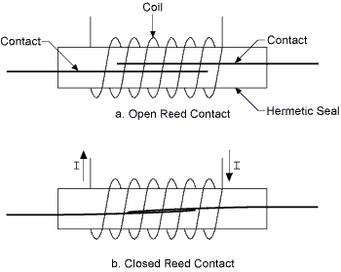

Fig 2.17.1 Reed Contacts

* 1. **Temperature And Humidity Sensing**

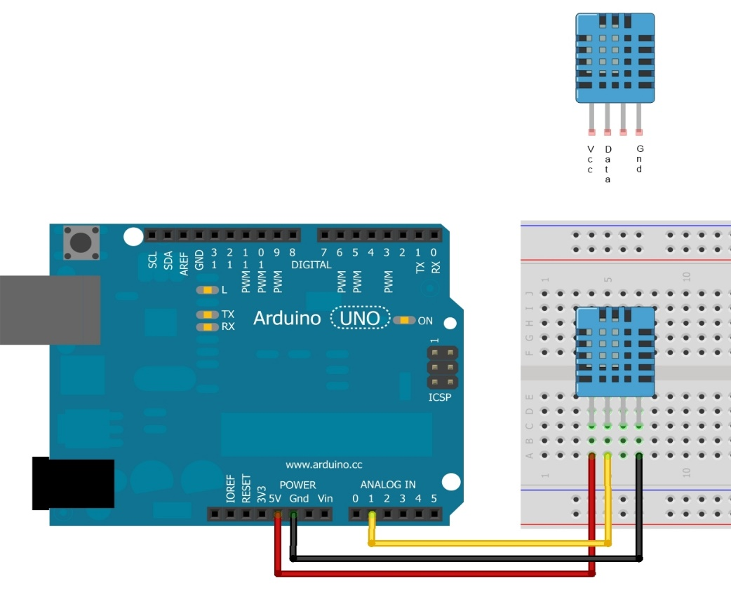

**ATMEGA 328**

Fig 3.2.10 Temperature and Humidity Sensing

The above schematic show how the digital temperature cum humidity sensor (DHT11) is connected to Arduino microcontroller.

It has 4 pins namely VCC, Ground, Output and NC where VCC is supplied with 5V and the digital output is sent to the Arduino where the DHT library is used to read both the temperature and humidity from the sensor.

The DHT11 is a basic, ultra low-cost digital temperature and humidity sensor. It uses a capacitive humidity sensor and a thermistor to measure the surrounding air, and spits out a digital signal on the data pin (no analog input pins needed). Its fairly simple to use, but requires careful timing to grab data. The only real downside of this sensor is you can only get new data from it once every 2 seconds, so when using some libraries, sensor readings can be up to 2 seconds old.

* 1. **Switching devices**

zm

**ATMEGA 328**

Fig 3.2.11 Switching Devices

The above schematic shows how any power system device like a light or fan is switched on or off via the microcontroller. A relay is connected to the GPIO pins of the Arduino microcontroller and a 5V DC supply is given to the relay to power it up.

Now, wires from the mains are taken and attached to the relay contacts to get the device setup. This relay is nothing but a switch which expects a control signal from the microcontroller thus powering up the appropriate power system device depending on which relay pin received the input. The above schematic shows a 4 channel relay.

The switching of the devices happen instantly and no delay is found unless there is a delay in the power system device to respond.

The relays also act as isolators avoiding flow of high AC voltage and current from the mains to the microcontroller. The module basically consists of 4 solid state relays connected together in a single PCB.

* 1. **RF Communication**

The nRF24L01+ is a single chip 2.4GHz transceiver that builds on the legacy of Nordic’s proven nRF24L01 wireless solution. The nRF24L01+ is fully drop-in compatible with the nRF24L01, mechanically, functionally and electrically. Enhancements over the nRF24L01 include improved wideband blocking and intermodulation performance. In addition, the inclusion of a fast front-end automatic gain control (AGC) further improves dynamic range and operational robustness in the presence of close proximity interferers. The net result is fewer retransmits, reduced average latency and lower average current consumption in noisy RF environments.

The nRF24L01+ features an up to 2Mbps (Mega bits per second) on-air data rate combined with ultra low power (ULP) operation and advanced power management. Peak transmit current is 11.3mA (at 0dB output power) and peak receive current is 13.5mA (at 2Mbps). The transceiver also features a 900nA power down mode, extending battery life. The nRF24L01+ runs at microampere average currents and can be powered from standard coin cell batteries for up to several years (depending on the application).

The nRF24L01+ extends the feature set of the nRF24L01 with a 250kbps data rate option that, by providing -94dBm sensitivity, can extend operating range by around 3x compared to operation in 1Mbps mode. This makes the chip an ideal ULP 2.4GHz transceiver for battery-powered RF applications that require maximum operating range without sacrificing battery life. The 250kbps mode is fully air compatible with the 250kbps mode in Nordic’s previous generation nRF2401A transceiver family (nRF2401, nRF2401A, nRF2402, nRF24E1, and nRF24E2), providing a direct migration path to a superior cost, power, and performance solution in existing designs.

Supplied in a compact 4x4mm package, the nRF24L01+ integrates a complete 2.4GHz RF transceiver, an RF synthesizer, and full baseband logic including the unique Enhanced ShockBurst™ hardware link layer (minimizing processing load on the host microcontroller reducing average current consumption), advanced power management, and a high-speed SPI for the host controller interface. No external loop filters, resonators or VCO varactor diodes are required, only a low cost ±60ppm 16MHz crystal, matching circuitry and the antenna.

The nRF24L01+’s Enhanced ShockBurst hardware link layer features both automatic packet handling and automatic packet transaction handling.

* Automatic packet handling key features include:
* Packet assembly
* Packet detection and validation
* Dynamic payload length
* MultiCeiver™ support for up to 6 bi-directional logical links for 1:6 star network topologies
* Automatic packet transaction handling key features include:
* Acknowledgment of received packages
* Payload in acknowledgment packet
* Retransmission of lost packages

Typical coin cell battery-powered applications for the nRF24L01+ include wristwatches and wireless sensors (e.g. heart rate monitors and foot pods used in sports products). Prime AA or AAA battery-powered application examples include wireless mice, keyboards, and RF remote controls that would benefit from battery lifetimes of up to one year.

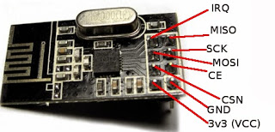

Fig 2.13.1 NRF24L01+ PIN Diagram

1. **Tools Used**

Fig 3.3 Tools Used

The above diagram shows the outline of the tools used in the making of the prototype. Detailed specifications have been given in the annexure and also along with the respective modules in the Methodology section.

1. **Software and Languages used**

Fig 3.4 Software & Languages Used

The languages listed in the diagram were used in the development of the prototype.

* PYTHON – To program the Raspberry PI
* C++ - To program the Arduino
* LINUX Shell – To work on the Raspberry PI interface
* HTML – To program the user interface skeleton
* CSS – To design the user interface
* JAVASCRIPT & Jquery – To allow user interactiveness and response
* PHP – To interact with the web server and the databases
* MySQL – To communicate between PHP & Database
* Adobe Phonegap – Development for Mobile platform (Future implementation)

**CHAPTER 4**

**RESULT ANALYSIS**

This chapter summarises the results and inference of the working model of the project when tested under different conditions.

Analysis of results yielded the following observations and inference:

* It is very important to calibrate the sensors before usage so that it will be error free.
* The connections made must be rechecked repeatedly so as to avoid any short which may lead to serious shock
* It is very important to have isolators or relays when controlling power system devices to avoid passing high AC/DC voltages to microcontrollers or microprocessors which may burn the device.
* It is very important to have a fuse so as to protect the equipments from any damage.
* The amplifier output comes with high noise which needs to be filtered before sending to ballast in lighting circuit.
* It is very important to check continuity of wires when soldering the circuit thus avoiding any possibility of short circuit.
* It is important to keep every Arduino substation in range with the Raspberry PI microprocessor so that the RF signals can reach the destination.

The prototype was tested and found to function properly at room temperatures and at temperatures close to 20 degree Celsius with normal humidity. The user interface is made database driven and the devices are controlled and monitored using the interface.

There was some delay found in RF communication whereas there was no delay found in communication over the internet. The results obtained are recorded and stored on a regular basis in databases and text files.

All the devices were found to communicate with the microprocessor and microcontroller synchronously and a common custom defined protocol was used to read the messages sent by each one of them.

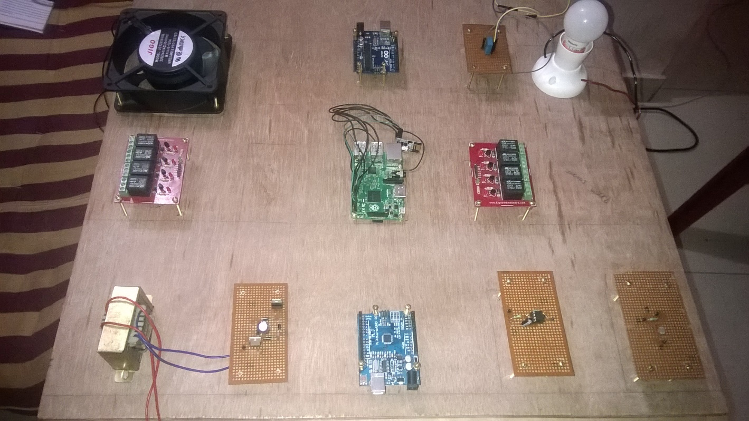

The above picture shows the sample of the prototype boards consisting of various modules with the microprocessor and microcontroller in the middle of the board since they act as the source of the control signal for all the power electronic controllers to control the power system devices.

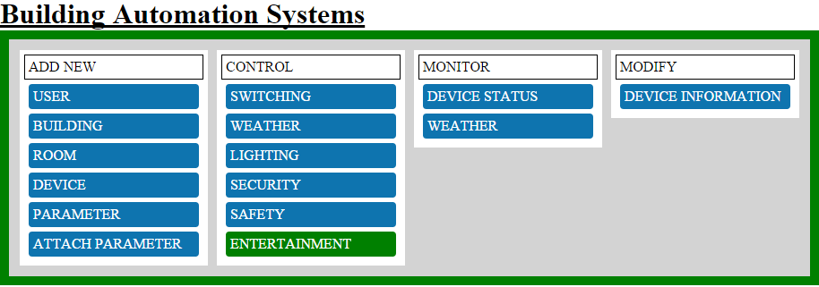

The above snapshot shows the user interface skeleton of the prototype from where the devices are controlled and monitored. The interface is made database driven with all the details stored on the server side. The user has the facility to control device switching, changing light intensity levels, monitoring security conditions and weather reports.

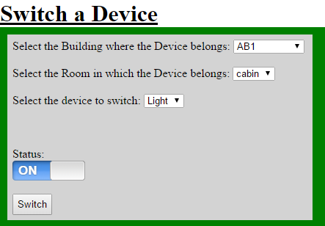

The above snapshot shows how a device is switched on or off with the interface. First, the room and device was selected and the status of the device was set to control the switching

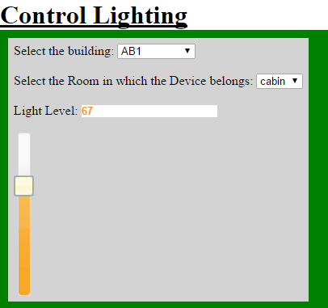 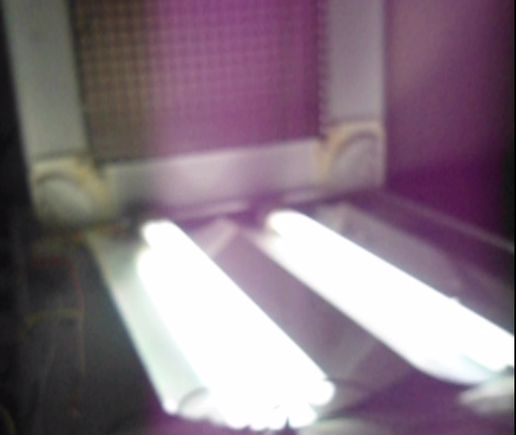

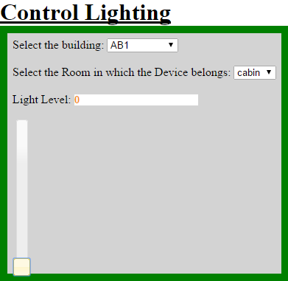 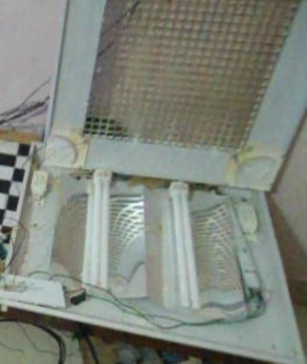

The above snapshots show the controlling of light intensity levels using the interface. The light levels were set in the interface which was reflected in the luminaire

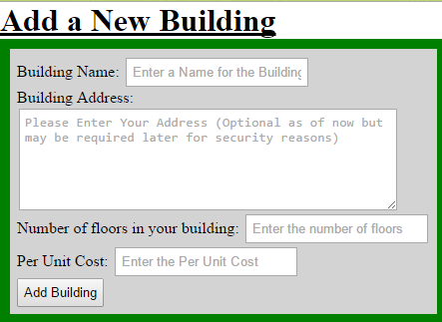

The above snapshot shows how a new building can be added so that automation can be done there. This is the future scope of the prototype.

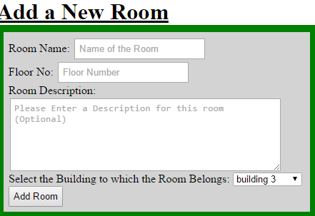

The above snapshot shows how a new room can be added to an already added building using the interface. This is the future scope of the prototype.

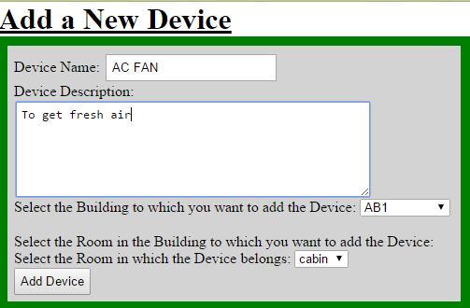

The above snapshot shows how a new device can be added to the system where the building and its room are already added. This is the future scope of the prototype

**CHAPTER 5**

**CONCLUSIONS & FUTURE SCOPE OF WORK**

**Summary:**

**5.1 Problem Statement:**

* To build a working prototype of Building Automation Systems.
* To remotely control every device through a user interface.

**5.2 Overall Working:**

* The user gives the command via user interface
* The command is sent to Raspberry PI microprocessor via internet
* The microprocessor sends the appropriate command to the Arduino substations via RF channel
* The Arduino microcontroller receives the command sent by the Raspberry PI microprocessor
* The received command is processed and appropriate action is taken by Arduino thus giving respective output to its GPIO pins
* The output is sensed and sent back to Arduino and then to Raspberry PI via RF thus forming a closed loop system

**5.3 Conclusion and Future Scope:**

* The prototype acts as a model for engineers on how to implement a real world Building Automation System
* It has the potential to save time for the user and make his/her work easy
* The future scope of this project may include implementation of voice recognition, artificial intelligence, fire safety systems, etc. thus making the system full-fledged.
* The future scope also involves making this project even more economical by choosing alternatives to devices currently being used

**CHAPTER 6**

**ANNEXURE**

1. **Device Specifications**

The following tables show a list of specifications for the devices used in the prototype.

1. **Electronic Ballast (WIPRO WBF80300)**

Table 6.1.1 Electronic Ballast Specifications

|  |  |
| --- | --- |
| **Supply Voltage** | 220-240V AC |
| **Supply Current** | 210mA-370mA |
| **Power Factor** | 0.98 |
| **Supply Frequency** | 50-60Hz |
| **Temperature Range** | 10 to 60 degree Celsius |

1. **Fluorescent Lamp**

Table 6.1.2 Fluorescent Lamp Specifications

|  |  |
| --- | --- |
| **Wattage** | 36W |
| **Lumens** | 2800 |

1. **DHT11 Temperature and Humidity Sensor**

Table 6.1.3 DHT11 Temperature and Humidity Sensor Specifications

|  |  |
| --- | --- |
| **Measurement Range** | 20-90% RH  0-50 degree Celsius |
| **Humidity Accuracy** | +5% or -5% RH |
| **Resolution** | 1 |

1. **RASPBERRY PI 2 MODEL B**

Table 6.1.4 Raspberry PI 2 Model B Specifications

|  |  |
| --- | --- |
| **Core** | A 900MHz quad-core ARM Cortex-A7 CPU |
| **RAM** | 1 GB |
| **USB PORTS** | 4 |
| **GPIO PINS** | 40 |
| **SD CARD SLOT** | Micro SD |
| **OPERATING SYSTEM** | LINUX BASED (Raspbian) |
| **GRAPHICS** | VideoCore IV 3D graphics core |

1. **ARDUINO UNO**

Table 6.1.5 Arduino UNO Specifications

|  |  |
| --- | --- |
| **MICROCONTROLLER** | ATmega328 |
| **Operating Voltage** | 5V |
| **Input Voltage (recommended)** | 7-12V |
| **Input Voltage (limits)** | 6-20V |
| **Digital I/O Pins** | 14 (of which 6 provide PWM output) |
| **Analog Input Pins** | 6 |
| **DC Current per I/O Pin** | 40 mA |
| **DC Current for 3.3V Pin** | 50 mA |
| **Flash Memory** | 32 KB (ATmega328) of which 0.5 KB used by bootloader |
| **SRAM** | 2 KB (ATmega328) |
| **EEPROM** | 1 KB (ATmega328) |
| **Clock Speed** | 16 MHz |
| **Length** | 68.6 mm |
| **Width** | 53.4 mm |
| **Weight** | 25 g |

1. **AC FAN**

Table 6.1.6 AC FAN Specifications

|  |  |
| --- | --- |
| **Size** | 120*120*38 mm |
| **Frequency** | 50/60 Hz |
| **Voltage** | 230V AC |
| **Current** | 100/90 mA |
| **Power** | 18W |
| **Speed** | 2600/2800 RPM |
| **Airflow** | 95/102 CFM |
| **Noise** | 42/45 dB |
| **Weight** | 500 gms |

**REFERENCES**

*Web*

1. Raspberry PI Configuration, Motion and door sensing, Adafruit
2. Sensor Interfacing, ModmyPI
3. Raspberry PI debugging, Raspberry PI Forums
4. Light Sensing & AC PWM Dimmer, Instructables
5. RF communication, Lenotta

Note: Many references used for the project have been recorded in <http://tinyurl.com/mybas> and have not been listed here to avoid any confusion.

PROJECT DETAILS

|  |  |  |  |  |
| --- | --- | --- | --- | --- |
| *Student Details* | | | | |
| **Student Name** | **T.V.VIGNESH** | | | |
| Register Number | 100906133 | | Section / Roll No | A-69 |
| Email Address | vigneshviswam@gmail.com | | Phone No (M) | 9535679593 |
| **Student Name** |  | | | |
| Register Number | 100906537 | | Section / Roll No | B-76 |
| Email Address | gaurav_anand17@yahoo.com | | Phone No (M) | 9035061887 |
|  | | | | |
| *Project Details* | | | | |
| **Project Title** | **PROTOTYPING OF BUILDING AUTOMATION SYSTEMS** | | | |
| Project Duration | 4.5 months | | Project Start Date | Jan 15th , 2015 |
|  | | | | |
| *Organization Details* | | | | |
| Organization Name | | **Manipal Institute of Technology, Manipal** | | |
| Full postal address with pin code | | Dept of Electrical & Electronics Engg, MIT Manipal, Manipal 576 104, Karnataka State, INDIA | | |
|  | |  | | |
| *Guide Details* | | | | |
| **Guide Name** | | **Mr. Vedavyasa Kamath** | | |
| Full contact address with pin code | | Dept of Electrical & Electronics Engg, MIT Manipal, Manipal 576 104, Karnataka State, INDIA | | |
| Email address | | [vedavyasa.kamath@manipal.edu](mailto:vedavyasa.kamath@manipal.edu) | | |